Revised Draft Chapter to appear in:

K. Johnson & M. Shiffrar (Eds.) Perception of the Human Body in Motion. Findings, Theory and Practice. Oxford University Press

From body perception to action preparation. A distributed neural system for viewing bodily expressions of emotion.

Beatrice de Gelder

¹ Cognitive and Affective Neuroscience Laboratory, Tilburg University, Tilburg, the Netherlands
² Martinos Center for Biomedical Imaging, Massachusetts General Hospital, Charlestown, Massachusetts

For better or worse, we spend our life surrounded by other people. Nothing is less surprising then than to assume that we are trained and over-trained to read their body language. When we see someone running with the hands protecting his face we perceive at once the fear and the action of running for cover. We rarely hesitate to assign meaning to such behaviors and we do not need to wait to recognize flight behavior till we are close by enough see the person’s facial expression. In daily life, failure to get cues from body language is seen as an indication of poor communication skills. Communication coaches, marketing gurus and therapists all concur to underline the importance of body language skills. But at present there is little scientific knowledge to support their enthusiasm for body language and there are still very few facts to build upon and to cultivate this ability. Indeed, until quite recently bodily expressions of emotion have not attracted much scientific interest. This is largely explained by the fact that cognitive and affective neuroscientists hitherto devoted their attention almost exclusively to facial expressions. This has led to an overwhelming number of studies on faces and facial expressions. To date there has been very little research on the body and action aspects of emotion perception. Current models of human emotion perception, based almost exclusively on studies of facial expressions, may underestimate the evolutionary role of affective signals. This role is not restricted to communicating internal states but includes an important component of perceiving the action linked to the emotional state and preparing the perceiver for adaptive action. Using bodies as stimuli provides a novel and unique opportunity to reveal these under-explored aspects.

As the example shows, recognition of bodily expressions involves visual perception and perception of the action and of its emotional significance. Furthermore, grasping the fear dimension in an action immediately alerts the observer to potential threat and prepares the organism for an adaptive reaction (de Gelder, Snyder, Greve, Gerard, & Hadjikhani, 2004). Depending on whether the stimulus is consciously seen and recognized, some of these processes may be associated with a conscious emotional experience. These are some of the main components of the ability to perceive bodily expressions. Based on results obtained so far, we have viewed them as the cornerstones of the three-networks model that was developed (de Gelder, 2006). In this chapter we present and discus more recent findings obtained in the course of testing some hypotheses derived from this model. Our point of departure is still the facial expression because that is at one the most studied emotional signal and the one by and large all human emotion theories are based on. By showing how bodily expressions are different, we gradually come closer to some central insights gained so far about bodily expression perception.

Why not bodies?
In view of the fact that many emotion theorists adhere to an evolutionary rationale which views emotions as leading to adaptive action, it is surprising that bodily expressions of these actions have not so far occupied a prominent place in emotion research. In stark contrast with the trust the layman puts in bodily signals, there seems to have been (and still is) a lingering suspicion that bodily expressions are more fluid, more subjective, more changeable, not providing the rock-bottom signals that faces do. Ekman, in his “quantity but not quality” theory, argues that bodily movements only provide information about the quantity or the intensity of emotion, but not about its quality or specificity (Ekman & Friesen, 1967). This view may have contributed to the almost exclusive focus on facial expressions in the last decades.

There are a number of reasons for this concentration on faces and for the lack of interest in bodies until recently (de Gelder, 2009). Some prejudices against the notion that bodily expressions are effortlessly recognized have historical roots within emotion science, like for example Ekman’s view just referred to. In parallel there is a complex web of social and cultural views and background assumptions that privilege the face and the facial expressions as the focus of human communication. For example, in the long tradition of western Cartesian mentalist psychology emotions have a moral component. The face is the window to the soul such that reading the face provided access to the person’s true states and inner feelings. With this traditional view we are miles away from a naturalistic perspective on emotions as adaptive actions as Darwin views them.

Contemporary affective science has strong reasons for turning our attention to bodily expressions and investing in this new field. To begin with, investigations of bodies will extend the scope of face-based research and provide evidence that human emotion theories based on studies of facial expression may generalize to other affective signals. A better understanding of bodily expressions will contribute to some long standing debates on why, all things considered, facial expressions viewed in isolation from any context, are often recognized less well than is routinely assumed. Besides that, investigating bodily expressions gives us a handle to address situations where the face is actively attended to but the facial and bodily expressions do not provide the same meaning and carry different messages for the viewer. This is important in situations where facial and bodily cues combine, interact, and possibly conflict as is for example the case when one manages to control ones facial expression but cannot or forgets to control the bodily posture.

Another motivation for bodily expression research is that facial and bodily expressions may have a certain degree of expressive specialisation. For all we know it may well be the case that that there is an emotion specialisation. Some emotions may be best expressed and recognized in the facial expression and others in the bodily expression. A clear case is disgust, which is mainly expressed in facial movements and much less by whole body movements. In contrast, it is easy to imagine that bodily expressions of anger are much stronger that facial expressions only and trigger in the viewer a different range of reactions and adaptive behaviors than does a facial expression only. Finally, the relative importance of communicating an emotion predominantly in the face vs. by the body may be gender as well as culture specific. It is a well knows fact that in some cultures, like for example in Japan, public displays of emotions in the face are discouraged. Interestingly, when Japanese observers are presented with stimuli consisting of facial expressions paired with sentence fragments spoken with affective prosody the latter influence more their rating of the facial expression than is the case in western observers (Tanaka et al., in press). Currently there are no data available on cross-cultural recognition of bodily expressions for Japanese observers.

I. Emotions as mental states or as actions.

At the core of the traditional view on human emotions is the intuition that emotions are subjective internal states and that we can access them by perceiving facial expressions. In this chapter we present arguments for an alternative view: bodily expressions reveal that at the core of emotional expressions there is a call to action.

Emotion psychologists traditionally assume that a perceiver is able to decode or extract emotional information from observable behaviors (e.g., facial expressions) and to learn something about the sender’s internal emotional state. This intuition has often been carried over into scientific studies of emotion. A familiar view is that decoding of an external signal revealing the inner state can take place automatically, to be largely innate (Buck, 2000; Izard, 1994), reflexive (Ekman, 1993), universal (Ekman, 1980), and corresponding more or less to natural kinds categories of emotion (Ekman, 1999; Izard, 1994; Tomkins, 1963). In line with this narrow focus, the main findings on the neurofunctional basis of emotion perception from the face consistently relate to the involvement of the amygdala (AMG), presumably the main brain structure for processing emotional signals, and the fusiform gyrus (FG) (Dolan, Morris, & de Gelder, 2001; Morris, Öhman, & Dolan, 1998; Rotshtein, Malach, Hadar, Graif, & Hendler, 2001), presumably the main brain area for processing faces. A feedback mechanism between the AMG to the FG explains coactivation, with AMG enhancing visual processing in the FG once the emotional salience of external events has been evaluated (Breiter et al., 1996; Morris et al., 1998; Sugase, Yamane, Ueno, & Kawano, 1999). This is a central finding in many reports over the last decade and it is supported by results from patients with AMG lesions in which such enhanced activity in the FG in response to facial expressions is absent (Vuilleumier, Richardson, Armony, Driver, & Dolan, 2004).

There is now already a substantial body of evidence from this last decade showing that emotions conveyed by bodily expressions are also quite easily recognized (see for a review de Gelder (2009)) and no less so than facial expressions. Some studies have approached the issue of the neurofunctional basis of body perception along the same lines as that of facial expressions by first identifying the core brain area that processes bodies and then looking whether this area is influenced by the affective significance represented in the body image. A first series of investigations of the time course and of the neurofunctional basis of emotional body processing using EEG, MEG and fMRI methods has already shown very clearly that bodily expressions convey emotions in ways very similar to facial expressions (de Gelder, 2006). This burgeoning interest in the body led to the argument that the human body may also represent a special perceptual category and have a dedicated neural basis (Downing, Jiang, Shuman, & Kanwisher, 2001). Note that this argument is typically made about neutral bodies. A review of the current literature shows that is not yet clear what role this body-specific area plays in processing emotional information (de Gelder et al., 2010).

Similar to the situation in face research some investigators are mainly interested in category specificity while others are more interested in functional networks. Our view is that in the case of facial expressions as well as in that of bodily expressions, one needs to go beyond questions of category-specific representation and formulate hypotheses about the functional role of the brain areas that process bodies. In our 2006 Nature Reviews Neuroscience paper we sketch a tentative three-network model of bodily expression processing (Figure 1). In the course of this chapter we present new evidence in support of our central thesis and elaborate some aspects of the original model.

The leading intuition behind a number of separate and detailed studies of bodily expression done in our lab and with our collaborators is that facial expressions tend to draw attention to the person and the mental state. In contrast, bodies are a unique means by which information about intended or executed actions is conveyed.

II. From faces to bodies.

Facial expressions are part of whole body expressions and it is not surprising that there are clear similarities in the ways in which each expresses emotions and conveys emotional signals. However, there are also major differences that are of considerable theoretical relevance.
Facial and bodily expressions may seem very similar because they normally convey the same emotion. Thus one expects that findings from three decades of human emotions research on facial expression carry over to bodily expressions. Our theoretical motivation for a comparison of facial and bodily expressions is to focus on what is special to bodies in order to capitalize on this as a mean of gaining new insights into the adaptive action aspect of emotions. It will allow us to build a bridge between the existing models of human emotion perception and the new approach developed here that includes bodily expressions.

Functional neuranatomy of bodily expressions.

Recent research provides already indirect evidence that bodies and faces have very similar behavioral, neurofunctional (Hadjikhani & de Gelder, 2003) and temporal correlates (Meeren, Hadjikhani, Ahlfors, Hamalainen, & de Gelder, 2008; Stekelenburg & de Gelder, 2004). Concerning the neurofunctional correlates, our first studies showed that the FG is equally sensitive to recognition of bodily fear signals (de Gelder et al., 2004; Hadjikhani & de Gelder, 2003; van de Riet, Grezes, & de Gelder, 2009). Those studies used still images but in later studies using videoclips the role of FG was also clear (Grèzes, Pichon, & de Gelder, 2007; Pichon, de Gelder, & Grezes, 2008, 2009). Interestingly, in a study comparing still images and videoclips we observed that some areas are sensitive to the presence of movement, some other ones to the presence of emotion and that some areas are revealed in the interaction between the presence of movement and the emotional information (Pichon et al., 2008). Recent studies have used dynamic stimuli and have proven useful for better understanding the respective contribution of action and emotion-related components. A study by Grosbras and Paus (2006) showed that video clips of angry hands trigger activations that largely overlap with those reported for facial expressions in the FG. Increased responses in STS and TPJ have been reported for dynamic threatening body expressions (Grèzes et al., 2007; Pichon et al., 2008, 2009). Whereas TPJ is implicated in higher level social cognitive processing (Decety & Lamm, 2007), STS has been frequently highlighted in biological motion studies (Allison, Puce, & McCarthy, 2000) and shows specific activity for goal-directed actions and configural and kinematics information from body movements (Bonda, Petrides, Ostry, & Evans, 1996; Grossman & Blake, 2002; Perrett et al., 1989; Thompson, Clarke, Stewart, & Puce, 2005). We return to this issue of the association between emotion and action networks in later sections.

Currently available direct evidence based on comparing facial and bodily expressions in one and the same study is still limited. Only one study has so far undertaken a direct comparison between faces and bodies and used still pictures (van de Riet et al., 2009). We performed a systematic comparison of how the whole brain processes faces and bodies and how their affective information is represented. Participants categorized emotional facial and bodily expressions while brain activity was measured using functional magnetic resonance imaging. Our results show that, first, the amygdala and the fusiform gyrus are sensitive to recognition of facial and bodily fear signals. Secondly, the extrastriate body area_area V5/MT is specifically involved in processing bodies without being sensitive to the emotion displayed. Thirdly, other important areas such as the superior temporal sulcus, the parietal lobe and subcortical structures represent selectively facial and bodily expressions. Finally, some face/body differences in activation are a function of the emotion expressed.

More recently we undertook a systematic comparison of the neurofunctional network dedicated to processing facial and bodily expressions. Two functional magnetic resonance imaging (fMRI) experiments investigated whether areas involved in processing social signals are activated differently by threatening signals (fear and anger) from facial or from bodily expressions. Amygdala (AMG) was more active for facial than bodily expressions. Yet it was no more activated by emotional than by neutral face videos. Emotional faces and bodies increased activity in the fusiform gyrus (FG), extrastriate body area (EBA), superior temporal sulcus (STS) and temporo-parietal junction (TPJ). EBA and STS were specifically modulated by threatening body language. FG was not differentially activated by threatening faces or bodies compared to neutral ones.

Our overall take on this is that bodily expressions activate more action perception structures, whereas faces trigger more activity in fine-grained analysis of the visual attributes. The overall difference between facial and bodily expressions can be framed at the neural level using the distinction between dorsal and ventral processing routes corresponding to bodies and faces, respectively.

Temporal dynamics of faces and bodies using EEG and MEG.

Information on the time-course of body-selective processing in the human brain has been obtained from non-invasive electrophysiological recordings. The deflections in the Event Related Potentials (ERP) of face and body perception show several similarities (Gliga & Dehaene-Lambertz, 2005; Meeren, van Heijnsbergen, & de Gelder, 2005; Righart & de Gelder, 2005; Stekelenburg & de Gelder, 2004; Thierry et al., 2006). Welke van Righart bedoel je? ERPs for faces as well as for bodies show a P1 and a prominent N1 component with similar scalp topography (Stekelenburg & de Gelder, 2004). The N1, better known as the “N170” in the case of face processing (a negative deflection at occipitotemporal electrodes peaking between 140-220 ms post stimulus onset), is thought to reflect a late stage in the structural encoding of the visual stimulus (Bentin, Allison, Puce, Perez, & McCarthy, 1996; Eimer, 2000). The mean peak latency of the N1 component for body processing has been found to range between 154 and 228 ms after stimulus onset (Gliga & Dehaene-Lambertz, 2005; Meeren et al., 2005; Minnebusch & Daum, 2009; Righart & de Gelder, 2005; Stekelenburg & de Gelder, 2004; Thierry et al., 2006; van Heijnsbergen, Meeren, Grezes, & de Gelder, 2007), similar as found for faces (for an overview see de de Gelder (2009). Table 1).

When faces and bodies are directly compared, the peak latency of the N1 for whole stimuli consisting of bodies with faces masked was found to be faster than that for faces (Meeren et al., 2005; Righart & de Gelder, 2005; Stekelenburg & de Gelder, 2004). For headless bodies the N1 is slower than that for faces (Gliga & Dehaene-Lambertz, 2005; Thierry et al., 2006). When analyzed at a higher spatial resolution, the body and face N1 showed a different spatial pattern, both in their potential distribution on the scalp (Gliga & Dehaene-Lambertz, 2005) and their corresponding source localizations in the brain (Thierry et al., 2006).

Different underlying neural generators for face and body perception in the N1 time-window were recently observed in a study using magnetoencephalography (MEG) with anatomically-constrained distributed source modelling (Meeren et al., submitted). Whereas both the ventral and lateral occipitotemporal cortex show strong responses during configural face processing, we could not find evidence for ventral activation during configural body processing. These neuromagnetic findings strongly argue against the proposed functional analogies between the face-sensitive and body-sensitive areas in the fusiform gyrus (FG) (Minnebusch & Daum, 2009; Taylor, Wiggett, & Downing, 2007).

The well-known electrophysiological inversion effect for faces, i.e. an increase in amplitude and latency of the N170 for stimuli shown upside down has also been found for bodies (Minnebusch & Daum, 2009; Righart & de Gelder, 2005; Stekelenburg & de Gelder, 2004; Taylor et al., 2007). The earlier inversion effect as observed for faces on the P1 component (~120 ms), could however not be found for bodies (Righart & de Gelder, 2007). Note in this context that the inversion effect needs to be assessed as the relative difference between the experimental stimulus and its control counterpart rather than direct comparisons between different stimulus categories with in latency and amplitude between a given stimulus and its upside down presented counterpart. Because of the sensitivity of ERP to physical stimulus differences direct comparisons between faces and bodies are misleading. Adopting that criterion we see that the inversion effect is of the same magnitude for faces and bodies (Stekelenburg & de Gelder, 2004).

Taking advantage of the sensitive time measurements that MEG provides may pursue this matter. We recently investigated the earliest onset of the electrophysiological inversion effect for different stimulus face and body categories (Meeren et al., 2008). Anatomically-constrained distributed source analyses revealed that both faces and bodies already show inversion effects between 70-100 ms post stimulus with larger responses for the inverted images. Interestingly the cortical distribution of this early inversion effect was highly category-specific. For faces it was found in well-known face-selective areas (e.g. the right inferior occipital gyrus (IOG) and midFG), whereas for bodies it was found in the posterio-dorsal medial parietal areas (the precuneus/posterior cingulate). Hence, whereas face inversion modulates early activity in face-selective areas in the ventral stream, body inversion evokes differential activity in dorsal stream areas, suggesting different early cortical pathways for configural face and body perception, and again different time courses of activation in the common neural substrate in the FG.

Taking together all currently available information on the time course of body and face processes prompts the conclusion that reports of comparative time courses must not be confined to the presence of a pre-defined marker (e.g. the face specific N170). We need to look at different time windows in different brain areas, some of which also activate during more than one single window. To conclude this section, there are similarities as well as differences in temporal dynamics and in neurofunctional basis between faces and bodies. The similarities just discussed allow us to build a bridge between the existing models of human emotion perception and the new findings on bodily expressions.

Bodies mean action: Perceiving bodily expressions is perceiving actions, triggers action preparation.

Finding out what does make bodily expression different from facial expressions may get us to the core of emotions as an evolutionary adaptive phenomenon. Bodily expressions provide a novel window on the evolutionary core of emotions because bodily expressions carry information about the agents’ adaptive action associated with the emotion displayed. This can be better achieved with the use of bodily expressions.

Bodily expression triggers action preparation in the observer.
Putting forward the action dimension leads to predictions about the different brain structures involved in perceiving facial and bodily expressions. As a first approximation the anatomical distinction between dorsal and ventral structures may be useful. Face images trigger emotion but at the same time identity or individual exemplar recognition, they will predominantly activate a ventral network (e.g., inferior occipital gyrus (IOG), FG). In contrast, individual identity recognition or fine-grained exemplar recognition is not needed to trigger emotion and action recognition. Bodily expressions will preferentially activate dorsal stream structures (superior temporal sulcus (STS), human motion areas (V5/MT), temporoparietal junction (TPJ), parietal cortex). As is the case for faces, currently available findings on perception of bodily expressions reveal not only a role for the FG but also for STS which is often linked to processing facial expressions, to social information and to biological movement perception (Allison et al., 2000; Baylis, Rolls, & Leonard, 1985; Bruce, Desimone, & Gross, 1981; Mikami, Nakamura, & Kubota, 1994; Perrett, Rolls, & Caan, 1982; Perrett et al., 1985; Pichon et al., 2008; Rolls, Baylis, & Hasselmo, 1987). Also important are and parietal structures and the insula (INS) and the orbitofrontal cortex (OFC) involved in the processing of emotional facial or bodily expressions (Adolphs, 2002; de Gelder, 2006; de Gelder et al., 2004; Wright, Santiago, & Sands, 1984). These regions, together with those involved in the perception of emotional and non-emotional faces and bodies, such as the primary somatosensory cortex (Adolphs, Damasio, Tranel, Cooper, & Damasio, 2000), comprise an extensive network in which face and body perception is implemented (van de Riet et al., 2009).

Attention and task demands differentially influence emotion and action aspects of bodily expressions.

Bodily expressions activate emotion and action structures but which of the involved structures is influenced by task demands and allocation of attention? This question is familiar from the face literature but is entirely novel for bodily expressions. So far it is still unclear whether the emotion and the action perception network involved in processing bodily expressions are similarly influenced by the task that directs the perceiver’s attention.

Recent experimental findings have shown that bilateral lesions of the AMG in humans do not impair the recognition of threat signals from body postures (Adolphs & Tranel, 2003; Atkinson, Heberlein, & Adolphs, 2007, but see Sprengelmeyer et al., 1999). Moreover, recent studies in AMG damaged patients have shown that impairment in perceiving fear signals is likely due to a failure in detecting salient visual cues (Adolphs, 2008) as patients recover normal fear recognition performances if instructed to attend the eye region (Adolphs et al., 2005; Spezio, Huang, Castelli, & Adolphs, 2007). Also lesions studies in young monkeys have shown that bilateral amygdalectomy disrupts fear processing and adequate expression, yet does not suppress fear behavior (Bauman, Lavenex, Mason, Capitanio, & Amaral, 2004; Prather et al., 2001), as long as subcortical structures such as periaquaductal grey (PAG) and hypothalamus remain intact (Fernandez De Molina & Hunsperger, 1962).

In a recent study (Tamietto, Geminiani, Genero, & de Gelder, 2007) we addressed the role of attention for perception of bodily expressions directly. The question was whether fearful bodily expressions modulate the spatial distribution of attention and enhances visual awareness in neurological patients with severe attentional disorders. Three such patients were tested with pictures of fearful, happy, and neutral bodily expressions briefly presented either unilaterally in the left or right visual field, or to both fields simultaneously. On bilateral trials, unattended and task-irrelevant fearful bodily expressions modulated attentional selection and visual awareness. Fearful bodily expressions presented in the contralesional unattended visual field simultaneously with neutral bodies in the ipsilesional field were detected more often than left-side neutral or happy bodies. This demonstrates that despite pathological inattention and parietal damage, emotion and action-related information in fearful body language may be extracted automatically, biasing attentional selection and visual awareness.

This raises the very important question of how these areas behave when the stimulus is fully visible but the observer is performing a task unrelated to the emotional information. What is the rationale for expecting continued processing of the affective information during performance of an unrelated and attention demanding task? If perceiving threat in others automatically triggers action preparation, it is adaptive to have this mechanism of automatic attentional shift always operational. Indeed, adaptive behavior requires a balance between the ability to perform a task efficiently, suppressing the influence of incoming distracters and the ability to detect significant signals arising in our environment even outside the current focus of attention. This is achievable at the cost of a relative degree of independence of certain brain regions from central processes. On the other hand, if perceiving emotional actions mainly consists in visuomotor representation of that action facilitating its understanding, there should be a difference between visuomotor representations of the perceived action for attended vs. unattended actions. Recent behavioral results have indeed suggested that the different allocation of spatial attention during action observation influences the execution of congruent/incongruent actions (Bach, Peatfield, & Tipper, 2007). Moreover, it has been shown that BA45 response was progressively reduced with increasing task demand during observation of grasping movements (Chong, Williams, Cunnington, & Mattingley, 2008). To the same extent, if the AMG and hypothalamus participate in the simulation of other’s fear and anger, one might expect their activity to be reduced when attention is not directed to the emotional content of the stimulus (Critchley et al., 2000). Investigating how selective attention influences the processing of threatening actions should therefore help to better understand the functional role of these structures.

An extensive literature in animal electrophysiology has shown that the AMG, hypothalamus and PAG (Bard, 1928; Blanchard & Blanchard, 1988; Cannon & Britton, 1925; McNaughton & Corr, 2004) play a central role in the physiology of defense when a fear inducing stimulus is present. Is a similar system active in the human brain, what are its components, can we sort out which components are involved in the action and which are involved in the emotion perception? How are these systems differentially influenced by attention? Behavioral and brainimaging studies shown that threat stimuli are salient signals that capture attention; i.e., they are prioritized in the process of attentional selection for the purpose of further processing (Fox & Damjanovic, 2006; Halgren et al., 1994; Hansen & Hansen, 1988; Öhman, Lundqvist, & Esteves, 2001; Palermo & Rhodes, 2007; Posner & Rothbart, 2007). Perceptual prioritizing rapidly and automatically shifts the orienting of attention and may rely upon the AMG (Anderson & Phelps, 2001; Whalen et al., 1998) which strongly responds to aversive information (Adolphs, Tranel, Damasio, & Damasio, 1995; Amaral, Bauman, & Schumann, 2003; LeDoux, 1995; Morris et al., 1996).

Recent investigations have shown that the relative automaticity of threat processing by the AMG could be altered under conditions of high perceptual load (Bishop, Jenkins, & Lawrence, 2007; Mitchell et al., 2007; Pessoa, McKenna, Gutierrez, & Ungerleider, 2002; Silvert et al., 2007). Therefore, although the perception of threat signals may be prioritized, it does still appear to be linked to the relative availability of attentional resources (Pessoa & Ungerleider, 2004).

However, complete independence of fear processing from attentional selection is currently a matter of debate. Pessoa and colleagues (Pessoa, Padmala, & Morland, 2005) have shown that when attentional resources are occupied by a competing and demanding task, AMG activation is significantly reduced. This has prompted the argument that without at least some attention devoted to it and some attentional available, an emotional signal is not automatically processed. This debate on the role of attention has so far been argued mostly in experiments with still images.

It is currently an open question whether processing of bodily expressions shown in video images requires attention. Videoclips of bodily expressions present emotional as well as action information. These two components may not be influenced by attention to the same extent. Observing threatening actions (as compared to neutral or joyful actions) increases activity in regions involved in action preparation: premotor cortex (PM), pre-supplementary motor area (pre-SMA) and inferior frontal gyrus (IFG) (de Gelder et al., 2004; Grèzes et al., 2007; Grosbras & Paus, 2006; Pichon et al., 2008, 2009). In addition, confrontation with anger signals increases activity in the amygdala and the hypothalamus (Pichon et al., 2009), two nuclei that are part of subcortico-cortical networks that interface with motor and autonomic systems important for the emotional experience of fear and rage (Adams, Gordon, Baird, Ambady, & Kleck, 2003; Barbas, 2000; Bard, 1928; Canteras, 2003; LeDoux, 2000; Panksepp, 1998; Sewards & Sewards, 2003; Siegel & Edinger, 1983).
The effects of salient stimuli on the attentional demands in visual perception have already been well explored but it remains largely unknown whether attention modulates activity in premotor regions and defense-related nuclei other than the amygdala (such as hypothalamus). While responses to threat in the amygdala and temporal cortex are altered when the perceptual load of a task is high, other brain regions may react relatively independently and continue to support adaptive behavior and action preparation whatever the task at hand. If so, motor-related regions will react differently to task conditions and attentional demands than will temporal regions.

We tested this prediction using functional magnetic resonance imaging. Participants watched movies of threatening and of neutral bodily actions. In one condition they were requested to name the color of a dot that appeared very briefly on the actor’s upper body (color-naming task) while in the other condition they named the emotional expression of the actor (emotion-naming task). The motivation to use a demanding color-task was to isolate threat-responsive regions independently of the task requirements. Moreover, we used dynamic actions expressing fear and anger as threatening signals, as they have been shown to elicit strong activations in subcortical and cortical regions important for preparation of defensive behaviour (de Gelder et al., 2004; Grèzes et al., 2007; Grosbras & Paus, 2006; Pichon et al., 2008, 2009).

Bodily expressions influence recognition of facial expressions.

Do bodily expressions influence the processing of simultaneously present facial expressions in an automatic fashion? Certainly the layman believes this to be the case. For example, candidate for a job interview get the advice not only to control their facial expression but also to keep their body language in check. In everyday life, facial expressions are usually not encountered in isolation but accompanied by a concurrent bodily expression. However, at close personal distance we may only attend to the facial expression and ignore the bodily expression. But we do this at our peril, as the bodily expression can sometimes carry an equally important, though contradictory message. Few studies have sorted out what actually happens in the brain of the observer when the facial and bodily expressions are both present and may be in conflict. The experiment will follow up on our previous EEG results (Meeren et al., 2005) and the goal is to investigate the neurofunctional basis of face/body (in)congruence and the influence of the body expression on the emotion recognized in the face. Stimuli, design and task will be adapted from our previous EEG study.

We predict that face and facial emotion sensitive regions will be more activated by emotional than by neutral expressions. Unattended, but normally visible, bodies should activate, via modulatory influence of the AMG, parietal areas related to exogenous attention. We also predict different patterns of brain activations for congruent vs. incongruent compounds with enhanced activity in PM areas for the former, whereas incongruent compounds result in an enhanced response in the anterior insula (AI) (Craig, 2009) and in anterior cingulate cortex, a region also involved in error-detection. Incongruent compounds will also trigger increased activation in OFC, but this pattern will be a function of the specific emotion of the bodily expression.

While perception without attention (i.e., evidence of visual processing of stimuli that nevertheless goes undetected because of lack of focused attention) is well documented, even if still controversial, perception without visual awareness remains under-investigated. It has so far proven methodologically difficult to implement a situation functionally similar to that of cortically blind patients in neurologically intact observers. By selectively manipulating stimulus visibility through backward masking, which is believed to provide temporary inhibition of the transient excitatory after-discharge of V1 neurons, we will create conditions functionally similar to striate cortex lesions in normal observers. All studies in this section will investigate body perception under conditions where the observer is not aware of the stimulus presence because effective masking objectively prevents normal conscious vision. This will allow us to study the specific contribution of perceptual awareness in EBL processing and to compare these effects to those related to perception without attention.

Backward masking is one of the most widely used techniques for exploring unconscious processing of visual emotional information in neurologically intact observers. Esteves and Öhman (1993) found that the presentation of an emotional face (happy and angry) for a short duration (e.g. 33 ms) which is replaced immediately with the presentation of a neutral face (mask) with a longer duration (e.g. 50 ms) is below identification threshold of participants. In most of the backward masking designs visibility of the target is measured subjectively in a separate post-test session. This clearly complicates the interpretation of many masking studies because visibility of the target co-varies with performance. To counter these methodological problems Lau and Passingham (2006) performed a metacontrast masking study. They presented their subjects with masked diamonds and squares and asked them in each trial to identify the target and subsequently to indicate whether they had seen the target. We used this masking paradigm to investigate perception of bodily expressions without visual awareness, as objectively measured with analyses derived from signal detection theory. In a psychophysical pilot study we used pictures of bodies expressing anger and happiness as targets. Multiple aspects of the pictures are controlled for such parameters as lighting, distance to the lens, contrast, luminance and actors clothing. The masks consisted of compounds of body parts (trunk, six arms and six legs in various positions) and were presented at 12 different SOAs varying from minus 50 to 133 milliseconds post stimulus onset. Participants categorize the expression of the target body in a forced-choice task and subsequently indicate whether they had seen the stimulus.

Conscious and nonconscious perception of facial and bodily expressions.

Emotional contagion refers to the rapid and unintentional transmission of affects across individuals and has been proposed as the precursor of more complex social abilities such as empathy (Iacoboni, 2009). Ambiguity nevertheless persists about the underlying processes. For example, it has been argued that emotional contagion is crucially based on mirror neurons (Carr, Iacoboni, Dubeau, Mazziotta, & Lenzi, 2003) which in turn trigger activation in emotion enters. However, much of the human data is obtained with fMRI studies that instruct the subjects to imagine themselve performing an action or to imitate an observed action (Carr et al., 2003; Nummenmaa, Hirvonen, Parkkola, & Hietanen, 2008). This procedure requires that the stimulus be visible to the subject and therefore cannot support strong claims about nonconscious processes.

A critical issue in most of the backward masking experiments concerns the measure adopted for visibility or visual awareness of the target. Most often this is assessed in a separate post test session or after each block rather than on a trial by trial basis. This clearly complicates the interpretation of masking studies because visibility of the target co-varies with the performance for each target presentation. Lau and Passingham (2006) performed an elegant masking study. They presented their participants with masked diamonds and squares and asked them on each trial to identify the target and, next, to indicate whether they had seen the target. The onset between target and mask (Stimulus Onset Asynchrony, SOA) parametrically varied. This method provided information about whether the participant was aware of the presence of a stimulus on a trial by trial basis and controls for the possibility that participants are likely to be more aware of the stimulus in the longer SOA trials. Lau and Passingham (2006) coined the term “relative blindsight” to refer to the phenomenon where participants were performing equally in the identification task but differed in reporting whether they had seen the target or not.
Using a comparable design we tested whether bodily expressions are processed outside awareness. Participants had to detect in separate experiments masked fearful, angry and happy bodily expressions among masked neutral bodily actions as distracters and subsequently the participants had to indicate their confidence. The onset between target and mask varied from -50 to +133 milliseconds. Using analyses derived from signal detection theory the results showed that the emotional bodily expressions could be detected reliably in all SOA conditions. Importantly, a phenomenon, which we refer to as relative affective blindsight was found, defined as two SOA conditions showing same recognition values, while the confidence ratings differed. In fact, this was only found for fearful bodily expressions, not for angry and happy bodily expressions.

We have recently investigated the role of visual stimulus awareness in two rare patients with cortical blindness in one half of their visual field following focal damage to the striate cortex (Tamietto et al., in press). Facial reactions were recorded using electromyography and arousal responses were measured with pupil dilatation. We showed that passive exposure to unseen expressions did evoke facial reactions and that moreover these were actually about 300ms faster compared to seen stimuli (see Fig. 6). This therefore indicates that emotional contagion occurs also when the triggering stimulus cannot be consciously perceived because of cortical blindness. Furthermore, facial and bodily expressions with very different visual characteristics, induced highly similar and emotion specific responses (Fig 6). This shows that the patients did not simply imitate the motor pattern observed in the stimuli, but rather resonated to their affective meaning. Another important finding from this study was that the affective reactions unfold even more rapidly and intensely when induced by a stimulus of which the subject is not aware is in line with data showing that emotional responses may be stronger when triggered by causes that remain inaccessible to introspection. For example, the peak amplitude of the EMG signal measured on the corrugator muscle, which is crucial for fear facial expressions, is over 200msec earlier for unseen stimuli. This difference in temporal dynamics is consistent with the neurophysiological properties of partly different pathways thought to sustain conscious vs. nonconscious emotional processing. Indeed, conscious emotional evaluation involves detailed perceptual analysis in cortical visual areas.

Models of bodily expression perception

In the last five years theoretical models of body perception have been formulated that were based either on a specifc contrast, like eg. Part vs. Whole perception (Urgesi, Candidi, Ionta, & Aglioti, 2007) and others were undertaken with the aim of integrating the available studies (de Gelder et al., 2004; de Gelder, 2006). The first one was based on the only fMRI data available at that time and presented systematically the many brain areas that showed differential activation for neutral compared to fearful bodily expressions (de Gelder et al., 2004). We distinguished five clusters of brain areas that come into play when participants passively observe fearful bodily expressions. At the visual perceptual level we distinguished between processes involved in body detection, with an important contribution of subcortical structures to detection and the more familiar occiptal-temporal cortical areas involved in visual analysis sustaining body perception and recognition. The third set of neurofunctional processes is involved in the representation of the affective information in the body images. Fourth, we observed that bodies trigger activation in areas know to represent action. Finally, and may be the most distinctive aspect, we found activations in premotor and motor areas that might be taken as evidence that seeing fearful bodies triggers action preparation. This was suggested by activity and cortical and subcortical areas related to motor response. It is worth noting though that none of these activations showed up when happy bodily expressons were contrasted with the same baseline. In this case the only differential activity was found in striate cortex. As we mentioned above, more recent studies, including the ones using videos, have revealed that this aspect of action preparation is very important (Sinket et al. 2010; Pichon, de Gelder & Grezes, submitted).

Integration of subsequent results with new information provided by other techniques as well as by lesion studies led to the model in de Gelder (2006) in which processing is envisaged along three interconnected routes, subcortical, cortical and interface systems. At the functional level there is a distinction betweeen three kinds of networks respectively implemeting reflex reactions to seeing bodily expressions, perception and recognition of bodily expressions and a third dimension implementing awareness of ones own bodily reactions to detecting and recognizing bodily expressions.

Models addressing a more specific range of data provided by studies of neutral still bodies and focussing on the issue of part versus whole processes in body perception are provided in (Hodzic, Kaas, Muckli, Stirn, & Singer, 2009; Taylor et al., 2007; Urgesi, Calvo-Merino, Haggard, & Aglioti, 2007). These models are reminiscent of the earlier models of face processing starting with Bruce and Young (1986) and other cognitive process models. Common to these models is that they tend to consist of a number of stages that are hierachically organized along a single time line, from more posterior. Each stage represents one step in the functional analysis of the stimulus converging on what is seen to be the central function. Thus the bruce and Young model of face perception focusses on the core business of face perception, which is recognition of personal identity is achieved. The latter function is still the center piece of a more distributed model like in Haxby, Hoffman, & Gobbini (2000). Other functions of the face like expression recognition are attributed to the extended face networkThis perspective and the notion that But as convergence grows between the researchers of face recognition in this narrow sense and those working on facial expression recognition a rapprochement is seen between the two kinds of models.

A major impetus for this rapprochement came from new findings on perception of facial expressions. A few studies showed that facial expressions were perceived at an “earlier” stage than envisaged in models in which encoding of the face structure preparatory fro acces to person recognition. These studies found expression specific activity in the time window of the P100 EEG wave, thus substantially earlier than N170 which at the time was viewd as the earliest marker of face specifity. Another novel finding was residual face processing ability in patients with cortical damage. This suggested that subcortical structures were to some extend involved in face processing which could take place outside visual awareness. These findings among others led to extended models of face processing encompassing both early and late processes, both expression and identity ((Adolphs, Tranel, & Damasio, 2003; de Gelder, Frissen, Barton, & Hadjikhani, 2003; de Gelder & Rouw, 2000) and involving conscious as well as unconscious, cortical but also subcortical structures and separate detection and recognition routes (de Gelder, 2000; de Gelder et al., 2003). As anticipated (de Gelder 2006) these distinctions also are needed to understand body perception. Currently available data on body and body expression perception indicate that at the neurofunctional basis is complex and will encompas subsystems for visual shape and movement analysis, for action representation, for representation of the affective significance, for reflexlike automatic action preparation and for reflective decision making of the action. Rather than envisaging a core and an extended system, a more distributed architecture consisting of different interconnected but dissociable networks seems to be needed. Furthermore, preferably to the assumption of a hierachical system along a single timeline, it is probably more useful for the time being to reckon with different timelines for each subsytem and to view these as running in parallel.

Figure 1

Figure reprinted form de Gelder 2006 (or redrawn)

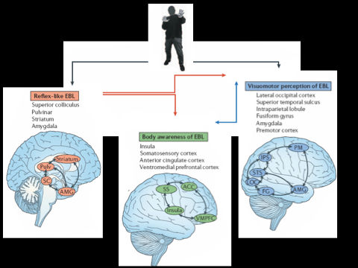

Figure 2

Figure 3

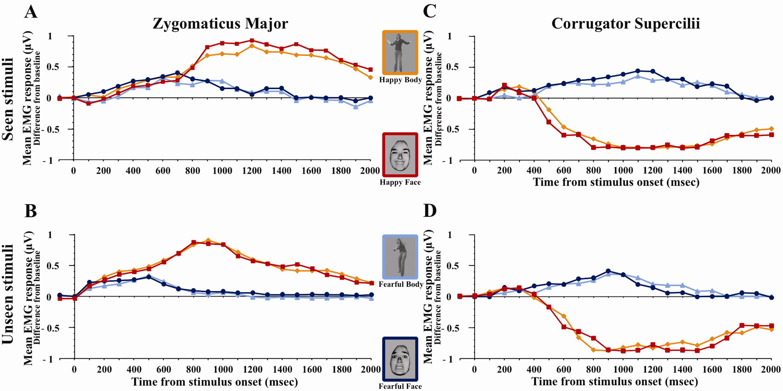

Figure 4

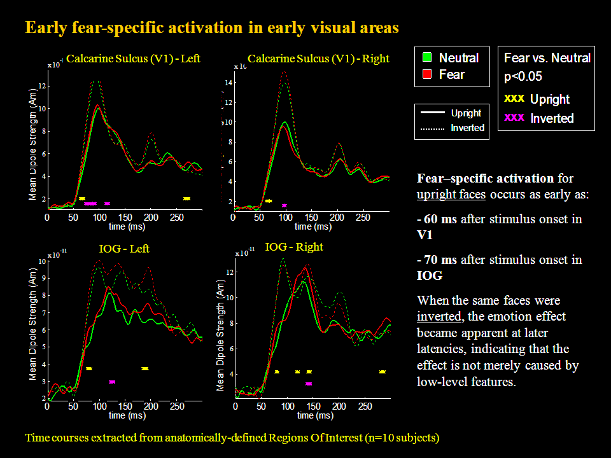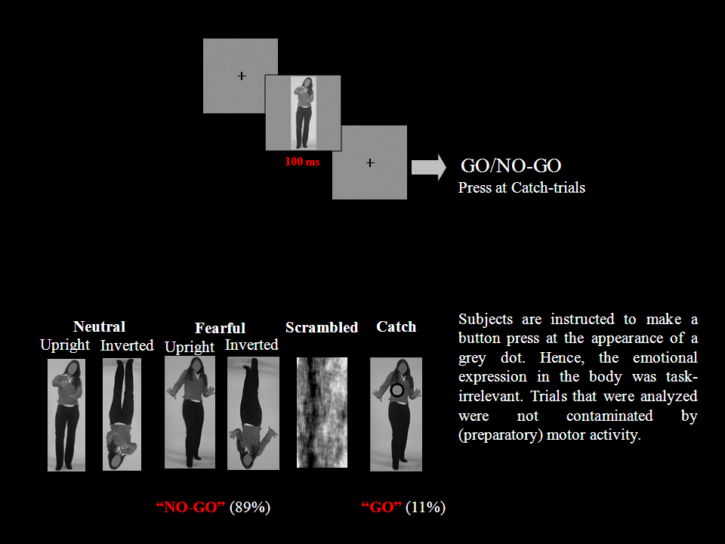

Figure 5

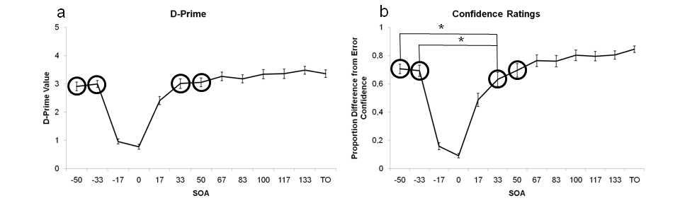

Figure legends.

Figure 1. The three interrelated network of emotional body processing. At the core of the model is the distinction between (i) a network sustaining reflex-like processes for preparing and executing rapid adaptive actions, (ii) a network at the service of perception-cognition-action representation involved in decision based action and (iii) bodily awareness processes. These three networks interact closely in normal emotional perception and cognition, but they can dissociate in clinical or neurological disorders (de Gelder, 2006).

Figure 2. Example of trial sequence for the neutral vs. fear blocks. Kret et al. Submitted.

Figure 3. EMG responses in patient D.B. (A) Mean responses in the ZM for seen stimuli. (B) Mean responses in the ZM for unseen stimuli. (C) Mean responses in the CS for seen stimuli. (D) Mean responses in the CS for unseen stimuli. Frame colour on the stimuli corresponds to coding of EMG response waveforms to the same class of stimuli. (From Tamietto et al., 2009 PNAS)

Figure 4. Left panel shows results obtained with facial expressions in V1 and IOG. Right panel shows and example of a trial for the bodily expression study, the stimuli used and the task consisting of reporting a dot superimposed on the stimulus.

Figure 5. The detection performance and confidence ratings in detecting fearful bodily expressions. Detecting fearful bodily expressions (a) seem to be equal at both sides of the U-shaped masking curve, while Confidence ratings (b) seem to differ for SOA value pairs -50 & 33 ms and -33 ms &+33 milliseconds, with lower confidence rating values when the bodily fearful expression is backwardly masked. Error bars indicate standard error mean. * = p < .05.

Acknowledgements. Preparation of this manuscript was partly supported by the Nederlandse Organisatie voor Wetenschappelijk Onderzoek, (NWO, 400.04081), Human Frontiers of Science Program RGP54/2004 and European Commission (COBOL FP6-NEST-043403) grants.

References

Adams, R. B., Jr., Gordon, H. L., Baird, A. A., Ambady, N., & Kleck, R. E. (2003). Effects of gaze on amygdala sensitivity to anger and fear faces. Science, 300(5625), 1536.
Adolphs, R. (2002). Neural systems for recognizing emotion. Opinion in Neurobiology, 12(2), 169-177.
Adolphs, R. (2008). Fear, faces, and the human amygdala. Current Opinion in Neurobiology, 18(2), 166-172.
Adolphs, R., Damasio, H., Tranel, D., Cooper, G., & Damasio, A. R. (2000). A role for somatosensory cortices in the visual recognition of emotion as revealed by three-dimensional lesion mapping. Journal of Neuroscience, 20(7), 2683-2690.
Adolphs, R., Gosselin, F., Buchanan, T. W., Tranel, D., Schyns, P., & Damasio, A. R. (2005). A mechanism for impaired fear recognition after amygdala damage. Nature, 433(7021), 68-72.
Adolphs, R., & Tranel, D. (2003). Amygdala damage impairs emotion recognition from scenes only when they contain facial expressions. Neuropsychologia, 41(10), 1281-1289.
Adolphs, R., Tranel, D., & Damasio, A. R. (2003). Dissociable neural systems for recognizing emotions. Brain and Cognition, 52(1), 61-69.
Adolphs, R., Tranel, D., Damasio, H., & Damasio, A. R. (1995). Fear and the human amygdala. Journal of Neuroscience, 15(9), 5879-5891.
Allison, T., Puce, A., & McCarthy, G. (2000). Social perception from visual cues: role of the STS region. Trends in Cognitive Sciences, 4(7), 267-278.
Amaral, D. G., Bauman, M. D., & Schumann, C. M. (2003). The amygdala and autism: implications from non-human primate studies. Genes, Brain and Behavior, 2(5), 295-302.
Anderson, A. K., & Phelps, E. A. (2001). Lesions of the human amygdala impair enhanced perception of emotionally salient events. Nature, 411(6835), 305-309.
Atkinson, A. P., Heberlein, A. S., & Adolphs, R. (2007). Spared ability to recognise fear from static and moving whole-body cues following bilateral amygdala damage. Neuropsychologia, 45(12), 2772-2782.
Bach, P., Peatfield, N. A., & Tipper, S. P. (2007). Focusing on body sites: the role of spatial attention in action perception. Experimental Brain Research, 178(4), 509-517.
Barbas, H. (2000). Connections underlying the synthesis of cognition, memory, and emotion in primate prefrontal cortices. Brain Research Bulletin, 52(5), 319-330.
Bard, P. (1928). A diencephalic mechanism for the expression of rage with special reference to the sympathetic nervous system. American Journal of Physiology, 84, 490-515.
Bauman, M. D., Lavenex, P., Mason, W. A., Capitanio, J. P., & Amaral, D. G. (2004). The development of social behavior following neonatal amygdala lesions in rhesus monkeys. Journal of Cognitive Neuroscience, 16(8), 1388-1411.
Baylis, G. C., Rolls, E. T., & Leonard, C. M. (1985). Selectivity between faces in the responses of a population of neurons in the cortex in the superior temporal sulcus of the monkey. Brain Research, 342(1), 91-102.
Bentin, S., Allison, T., Puce, A., Perez, E., & McCarthy, G. (1996). Electrophysiological studies of face perception in humans. Journal of Cognitive Neuroscience., 8(6), 551-565.
Bishop, S. J., Jenkins, R., & Lawrence, A. D. (2007). Neural processing of fearful faces: effects of anxiety are gated by perceptual capacity limitations. Cerebral Cortex, 17(7), 1595-1603.
Blanchard, D. C., & Blanchard, R. J. (1988). Ethoexperimental approaches to the biology of emotion. Annual Review of Psychology, 39, 43-68.
Bonda, E., Petrides, M., Ostry, D., & Evans, A. (1996). Specific involvement of human parietal systems and the amygdala in the perception of biological motion. Journal of Neuroscience, 16(11), 3737-3744.
Breiter, H. C., Etcoff, N. L., Whalen, P. J., Kennedy, W. A., Rauch, S. L., Buckner, R. L., et al. (1996). Response and habituation of the human amygdala during visual processing of facial expression. Neuron, 17(5), 875-887.
Bruce, C., Desimone, R., & Gross, C. G. (1981). Visual properties of neurons in a polysensory area in superior temporal sulcus of the macaque. Journal of Neurophysiology, 46(2), 369-384.
Bruce, V., & Young, A. W. (1986). Understanding face recognition. British Journal of Psychology, 77, 305-327.
Buck, R. (2000). The epistemology of reason and affect. In J. Borod (Ed.), The neuropsychology of emotion. (pp. 31-55). Oxford: Oxford University Press.
Cannon, W. B., & Britton, S. W. (1925). Studies on the conditions of activity in endocrine glands. American Journal of Physiology, 72, 283-284.
Canteras, N. S. (2003). Critical analysis of the neural systems organizing innate fear responses. Revista Brasileira de Psiquiatria, 25 Suppl 2, 21-24.
Carr, L., Iacoboni, M., Dubeau, M. C., Mazziotta, J. C., & Lenzi, G. L. (2003). Neural mechanisms of empathy in humans: a relay from neural systems for imitation to limbic areas. Proceedings of the National Academy of Sciences U S A, 100(9), 5497-5502.
Chong, T. T., Williams, M. A., Cunnington, R., & Mattingley, J. B. (2008). Selective attention modulates inferior frontal gyrus activity during action observation. Neuroimage, 40(1), 298-307.
Craig, A. D. (2009). How do you feel--now? The anterior insula and human awareness. Nature Reviews Neuroscience, 10(1), 59-70.
Critchley, H., Daly, E., Phillips, M., Brammer, M., Bullmore, E., Williams, S., et al. (2000). Explicit and implicit neural mechanisms for processing of social information from facial expressions: a functional magnetic resonance imaging study. Human Brain Mapping, 9(2), 93-105.
de Gelder, B. (2000). More to seeing than meets the eye. Science, 289(5482), 1148-1149.
de Gelder, B. (2006). Towards the neurobiology of emotional body language. Nature Reviews Neuroscience, 7(3), 242-249.
de Gelder, B. (2009). Why bodies? Twelve reasons for including bodily expressions in affective neuroscience. Philosophical Transactions of the Royal Society B: Biological Sciences, 364(1535), 3475-3484.
de Gelder, B., Frissen, I., Barton, J., & Hadjikhani, N. (2003). A modulatory role for facial expressions in prosopagnosia. Proceedings of the National Academy of Sciences U S A, 100(22), 13105-13110.
de Gelder, B., & Rouw, R. (2000). Configural face processes in acquired and developmental prosopagnosia: evidence for two separate face systems? Neuroreport, 11(14), 3145-3150.
de Gelder, B., Snyder, J., Greve, D., Gerard, G., & Hadjikhani, N. (2004). Fear fosters flight: A mechanism for fear contagion when perceiving emotion expressed by a whole body. Proceedings of the National Academy of Sciences, 101(47), 16701-16706.
de Gelder, B., Van den Stock, J., Meeren, H. K., Sinke, C. B., Kret, M. E., & Tamietto, M. (2010). Standing up for the body. Recent progress in uncovering the networks involved in processing bodies and bodily expressions. Neuroscience and Biobehavioral Reviews, 34(4), 513-527.
Decety, J., & Lamm, C. (2007). The role of the right temporoparietal junction in social interaction: how low-level computational processes contribute to meta-cognition. Neuroscientist, 13(6), 580-593.
Dolan, R. J., Morris, J. S., & de Gelder, B. (2001). Crossmodal binding of fear in voice and face. Proceedings of the National Academy of Sciences of the United States of America, 98(17), 10006-10010.
Downing, P. E., Jiang, Y., Shuman, M., & Kanwisher, N. (2001). A cortical area selective for visual processing of the human body. Science, 293(5539), 2470-2473.
Eimer, M. (2000). The face-specific N170 component reflects late stages in the structural encoding of faces. Neuroreport, 11(10), 2319-2324.
Ekman, P. (1980). Biological and Cultural Contributions to Body and Facial Movement in the Expression of Emotion. In A. O. Rorty (Ed.), Explaining emotions (pp. 73-101). Berkeley: University of California Press.
Ekman, P. (1993). Facial expression and emotion. American Psychologist, 48(4), 384-392.
Ekman, P. (1999). Basic Emotions. In T. Dalgleish & M. J. Power (Eds.), Handbook of Cognition and Emotion (pp. 45-60). New York, NY: John Wiley & Sons Ltd.
Ekman, P., & Friesen, W. V. (1967). Head and body cues in the judgment of emotion: a reformulation. Perceptual and Motor Skills, 24(3), 711-724.
Esteves, F., & Ohman, A. (1993). Masking the face: recognition of emotional facial expressions as a function of the parameters of backward masking. Scandinavian Journal of Psychology, 34(1), 1-18.
Fernandez De Molina, A., & Hunsperger, R. W. (1962). Organization of the subcortical system governing defence and flight reactions in the cat. The Journal of Physiology, 160, 200-213.
Fox, E., & Damjanovic, L. (2006). The eyes are sufficient to produce a threat superiority effect. Emotion, 6(3), 534-539.
Gliga, T., & Dehaene-Lambertz, G. (2005). Structural encoding of body and face in human infants and adults. Journal of Cognitive Neuroscience, 17, 1328-1340.
Grèzes, J., Pichon, S., & de Gelder, B. (2007). Perceiving fear in dynamic body expressions. Neuroimage, 35(2), 959-967.
Grosbras, M. H., & Paus, T. (2006). Brain networks involved in viewing angry hands or faces. Cerebral Cortex, 16(8), 1087-1096.
Grossman, E. D., & Blake, R. (2002). Brain Areas Active during Visual Perception of Biological Motion. Neuron, 35(6), 1167-1175.
Hadjikhani, N., & de Gelder, B. (2003). Seeing fearful body expressions activates the fusiform cortex and amygdala. Current Biology, 13(24), 2201-2205.
Halgren, E., Baudena, P., Heit, G., Clarke, J. M., Marinkovic, K., & Clarke, M. (1994). Spatio-temporal stages in face and word processing. I. Depth-recorded potentials in the human occipital, temporal and parietal lobes. Journal of Physiology - Paris, 88(1), 1-50.
Hansen, C. H., & Hansen, R. D. (1988). Finding the face in the crowd: an anger superiority effect. Journal of personality and social psychology, 54(6), 917-924.
Haxby, J. V., Hoffman, E. A., & Gobbini, M. I. (2000). The distributed human neural system for face perception. Trends in Cognitive Sciences 4(6), 223-233.
Hodzic, A., Kaas, A., Muckli, L., Stirn, A., & Singer, W. (2009). Distinct cortical networks for the detection and identification of human body. Neuroimage, 45(4), 1264-1271.
Iacoboni, M. (2009). Imitation, empathy, and mirror neurons. Annual Review of Psychology, 60, 653-670.
Izard, C. E. (1994). Innate and universal facial expressions: evidence from developmental and cross-cultural research. Psychol Bull, 115(2), 288-299.
Lau, H. C., & Passingham, R. E. (2006). Relative blindsight in normal observers and the neural correlate of visual consciousness. Proceedings of the National Academy of Sciences of the United States of America, 103(49), 18763-18768.
LeDoux, J. E. (1995). Emotion: clues from the brain. Annual Review of Psychology, 46, 209-235.
LeDoux, J. E. (2000). Emotion circuits in the brain. Annual Review of Neuroscience, 23, 155-184.
McNaughton, N., & Corr, P. J. (2004). A two-dimensional neuropsychology of defense: fear/anxiety and defensive distance. Neuroscience & Biobehavioral Reviews, 28(3), 285-305.
Meeren, H. K., Hadjikhani, N., Ahlfors, S. P., Hamalainen, M. S., & de Gelder, B. (2008). Early category-specific cortical activation revealed by visual stimulus inversion. PLoS ONE, 3(10), e3503.
Meeren, H. K., van Heijnsbergen, C. C., & de Gelder, B. (2005). Rapid perceptual integration of facial expression and emotional body language. Proceedings of the National Academy of Sciences U S A, 102(45), 16518-16523.
Mikami, A., Nakamura, K., & Kubota, K. (1994). Neuronal responses to photographs in the superior temporal sulcus of the rhesus monkey. Behavioural Brain Research, 60(1), 1-13.
Minnebusch, D. A., & Daum, I. (2009). Neuropsychological mechanisms of visual face and body perception. Neuroscience & Biobehavioral Reviews, 33(7), 1133-1144.
Mitchell, D. G. V., Nakic, M., Fridberg, D., Kamel, N., Pine, D. S., & Blair, R. J. R. (2007). The impact of processing load on emotion. NeuroImage, 34(3), 1299-1309.
Morris, J. S., Frith, C. D., Perrett, D. I., Rowland, D., Young, A. W., Calder, A. J., et al. (1996). A differential neural response in the human amygdala to fearful and happy facial expressions. Nature, 383(6603), 812-815.
Morris, J. S., Öhman, A., & Dolan, R. J. (1998). Conscious and unconscious emotional learning in the human amygdala. Nature, 393(6684), 467-470.
Nummenmaa, L., Hirvonen, J., Parkkola, R., & Hietanen, J. K. (2008). Is emotional contagion special? An fMRI study on neural systems for affective and cognitive empathy. Neuroimage, 43(3), 571-580.
Öhman, A., Lundqvist, D., & Esteves, F. (2001). The face in the crowd revisited: a threat advantage with schematic stimuli. Journal of Personality and Social Psychology, 80(3), 381-396.
Palermo, R., & Rhodes, G. (2007). Are you always on my mind? A review of how face perception and attention interact. Neuropsychologia, 45(1), 75-92.
Panksepp, J. (1998). Affective neuroscience: The foundation of human and animal emotions. New York: Oxford University Press.
Perrett, D. I., Harries, M. H., Bevan, R., Thomas, S., Benson, P. J., Mistlin, A. J., et al. (1989). Frameworks of analysis for the neural representation of animate objects and actions. Journal of Experimental Biology, 146, 87-113.
Perrett, D. I., Rolls, E. T., & Caan, W. (1982). Visual neurones responsive to faces in the monkey temporal cortex. Experimental Brain Research, 47(3), 329-342.
Perrett, D. I., Smith, P. A., Potter, D. D., Mistlin, A. J., Head, A. S., Milner, A. D., et al. (1985). Visual cells in the temporal cortex sensitive to face view and gaze direction. Proceedings of the Royal Society of London. Series B: Biological Sciences, 223(1232), 293-317.
Pessoa, L., McKenna, M., Gutierrez, E., & Ungerleider, L. G. (2002). Neural processing of emotional faces requires attention. Proceedings of the National Academy of Sciences, 99(17), 11458-11463.
Pessoa, L., Padmala, S., & Morland, T. (2005). Fate of unattended fearful faces in the amygdala is determined by both attentional resources and cognitive modulation. Neuroimage, 28(1), 249-255.
Pessoa, L., & Ungerleider, L. G. (2004). Neuroimaging studies of attention and the processing of emotion-laden stimuli. Progress in Brain Research, 144, 171-182.
Pichon, S., de Gelder, B., & Grezes, J. (2008). Emotional modulation of visual and motor areas by dynamic body expressions of anger. Social Neuroscience, 3(3-4), 199-212.
Pichon, S., de Gelder, B., & Grezes, J. (2009). Two different faces of threat. Comparing the neural systems for recognizing fear and anger in dynamic body expressions. Neuroimage, 47(4), 1873-1883.
Posner, M. I., & Rothbart, M. K. (2007). Research on attention networks as a model for the integration of psychological science. Annual Review of Psychology, 58, 1-23.
Prather, M. D., Lavenex, P., Mauldin-Jourdain, M. L., Mason, W. A., Capitanio, J. P., Mendoza, S. P., et al. (2001). Increased social fear and decreased fear of objects in monkeys with neonatal amygdala lesions. Neuroscience, 106(4), 653-658.
Righart, R., & de Gelder, B. (2007). Impaired face and body perception in developmental prosopagnosia. Proceedings of the National Academy of Sciences, 104(43), 17234-17238.
Rolls, E. T., Baylis, G. C., & Hasselmo, M. E. (1987). The responses of neurons in the cortex in the superior temporal sulcus of the monkey to band-pass spatial frequency filtered faces. Vision Research, 27(3), 311-326.
Rotshtein, P., Malach, R., Hadar, U., Graif, M., & Hendler, T. (2001). Feeling or features: different sensitivity to emotion in high-order visual cortex and amygdala. Neuron, 32(4), 747-757.
Sewards, T. V., & Sewards, M. A. (2003). Fear and power-dominance motivation: proposed contributions of peptide hormones present in cerebrospinal fluid and plasma. Neuroscience and Biobehavioral Reviews, 27(3), 247-267.
Siegel, A., & Edinger, H. M. (1983). Role of the limbic system in hypothalamically elicited attack behavior. Neuroscience and Biobehavioral Reviews, 7(3), 395-407.
Silvert, L., Lepsien, J., Fragopanagos, N., Goolsby, B., Kiss, M., Taylor, J. G., et al. (2007). Influence of attentional demands on the processing of emotional facial expressions in the amygdala. NeuroImage, 38(2), 357-366.
Spezio, M. L., Huang, P. Y., Castelli, F., & Adolphs, R. (2007). Amygdala damage impairs eye contact during conversations with real people. J Neurosci, 27(15), 3994-3997.
Sprengelmeyer, R., Young, A. W., Schroeder, U., Grossenbacher, P. G., Federlein, J., Buttner, T., et al. (1999). Knowing no fear. Proceedings. Biological sciences / The Royal Society, 266(1437), 2451-2456.
Stekelenburg, J. J., & de Gelder, B. (2004). The neural correlates of perceiving human bodies: an ERP study on the body-inversion effect. Neuroreport, 15(5), 777-780.
Sugase, Y., Yamane, S., Ueno, S., & Kawano, K. (1999). Global and fine information coded by single neurons in the temporal visual cortex. Nature, 400(6747), 869-873.
Tamietto, M., Castelli, L., Vighetti, S., Perozzo, P., Geminiani, G., Weiskrantz, L., et al. (in press). Blindly led by emotions. Nonconscious emotional contagion for facial and bodily expressions. Proceedings of the National Academy of Sciences, U.S.A.
Tamietto, M., Geminiani, G., Genero, R., & de Gelder, B. (2007). Seeing fearful body language overcomes attentional deficits in patients with neglect. Journal of Cognitive Neuroscience, 19(3), 445-454.
Tanaka, A., Koizumi, A., Imai, H., Hiramatsu, S., Hiramoto, E., & de Gelder, B. (in press). I feel your voice: Cultural differences in the multisensory perception of emotion. Psychological Science.
Taylor, J. C., Wiggett, A. J., & Downing, P. E. (2007). Functional MRI analysis of body and body part representations in the extrastriate and fusiform body areas. Journal of Neurophysiology, 98(3), 1626-1633.
Thierry, G., Pegna, A. J., Dodds, C., Roberts, M., Basan, S., & Downing, P. (2006). An event-related potential component sensitive to images of the human body. Neuroimage, 32(2), 871-879.
Thompson, J. C., Clarke, M., Stewart, T., & Puce, A. (2005). Configural processing of biological motion in human superior temporal sulcus. Journal of Neuroscience, 25(39), 9059-9066.
Tomkins, S. S. (1963). Affect, imagery consciousness: Vol. 2. The negative affects. In. New York: Springer verlag.
Urgesi, C., Calvo-Merino, B., Haggard, P., & Aglioti, S. M. (2007). Transcranial magnetic stimulation reveals two cortical pathways for visual body processing. Journal of Neuroscience, 27(30), 8023-8030.
Urgesi, C., Candidi, M., Ionta, S., & Aglioti, S. M. (2007). Representation of body identity and body actions in extrastriate body area and ventral premotor cortex. Nature Neuroscience, 10(1), 30-31.
van de Riet, W. A., Grezes, J., & de Gelder, B. (2009). Specific and common brain regions involved in the perception of faces and bodies and the representation of their emotional expressions. Social Neuroscience, 4(2), 101-120.
van Heijnsbergen, C. C., Meeren, H. K., Grezes, J., & de Gelder, B. (2007). Rapid detection of fear in body expressions, an ERP study. Brain Research, 1186, 233-241.
Vuilleumier, P., Richardson, M. P., Armony, J. L., Driver, J., & Dolan, R. J. (2004). Distant influences of amygdala lesion on visual cortical activation during emotional face processing. Nature Neuroscience, 7(11), 1271-1278.
Whalen, P. J., Rauch, S. L., Etcoff, N. L., McInerney, S. C., Lee, M. B., & Jenike, M. A. (1998). Masked presentations of emotional facial expressions modulate amygdala activity without explicit knowledge. Journal of Neuroscience, 18(1), 411-418.
Wright, A. A., Santiago, H. C., & Sands, S. F. (1984). Monkey memory: same/different concept learning, serial probe acquisition, and probe delay effects. Journal of Experimental Psychology: Animal Behavior Processes, 10(4), 513-529.

